UTAH PONY OF THE AMERICAS CLUB
2023 Rocky Mountain Regional & West World Show

Award Sponsorship Form

The Utah POAC is hosting in 2023 the prestigious Rocky Mountain Regional, and West World shows. These shows held back to back will be 4 days, and will bring competitors from all around the country to our beautiful state. These will be exciting and well-attended shows. Any donation that you can provide is very generous and we thank you for your support to help us foster an environment where exhibitors can dream big, believe in themselves and others, and achieve great successes.
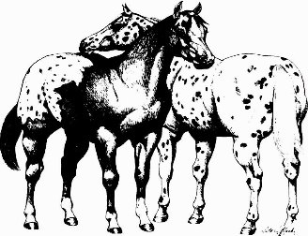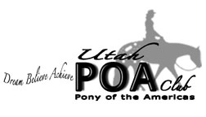

Bronze Level Sponsor- $100 or More-Social media coverage for you, and or your business, inclusion in sponsor thank you page in the show packet and announcements over the course of the show

Silver Level Sponsor- $250 or More- Prominent signage (provided by sponsor) around events, social media coverage for you, and or your business, inclusion in sponsor thank you page in the show packet, and several announcements over the course of the show. With an option to sponsor any specific classes.

Gold Level Sponsor- $500 or more- Prominent signage (provided by sponsor) around events, social media coverage for you, and or your business, inclusion in sponsor thank you page in the show packet, and several announcements at each show over the course of the shows. With an option to sponsor one of our high point awards, or age group, or class of each sponsors choosing.

Platinum Level Sponsor- $1000 or More- Prominent signage (provided by sponsor) around events, social media coverage for you, and or your business, inclusion in sponsor thank you page in the show packet, and several announcements at each show including the opening of each show, and over the course of the show. With the option to sponsor one of our all-around high point awards, high point awards, or age group, or class of each sponsors choosing.

